LAB 3 – Operating System

Part F –

26 to 33

Used `sudo sh` after this to execute rest of the commands in elevated state

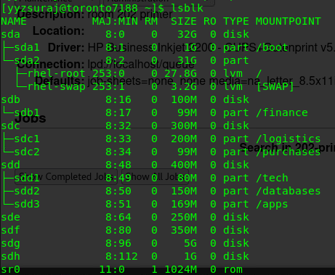

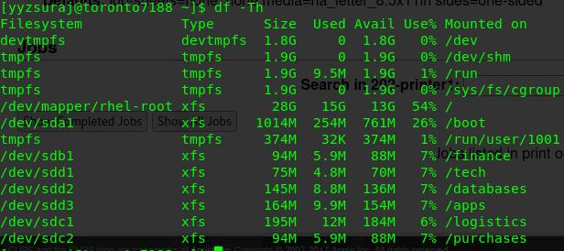

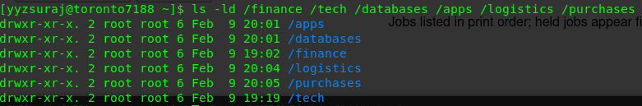

Part G –

Part J –

41 -

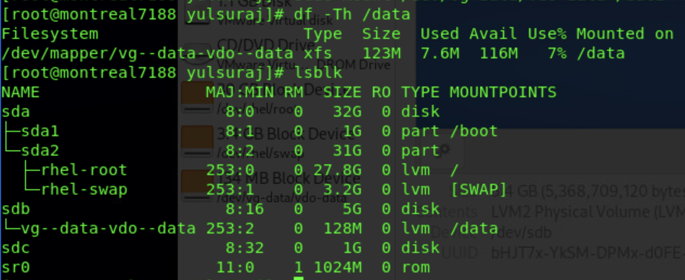

Part K – All commands are run with elevated permissions (sudo su) hence no sudo in the following screenshots

42 -

Montreal

43 – new password is `root` for both yyz & yul

44 –

45-

